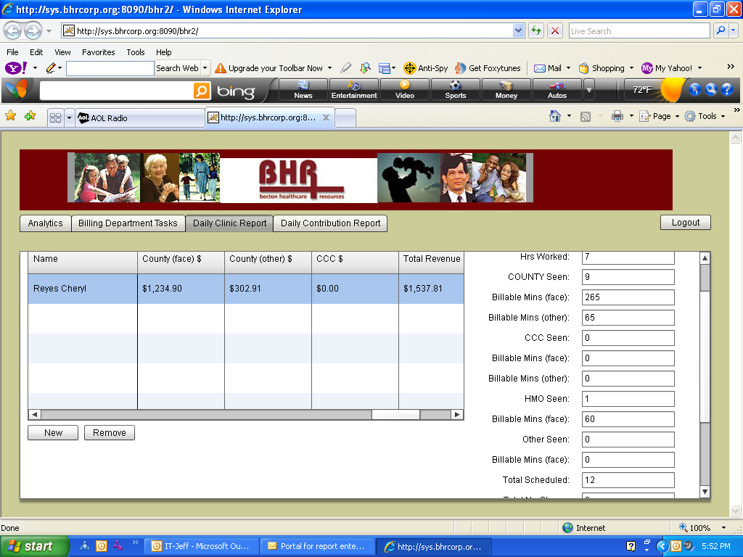
Not deducting Daily Salary to Total revenue like it did before.
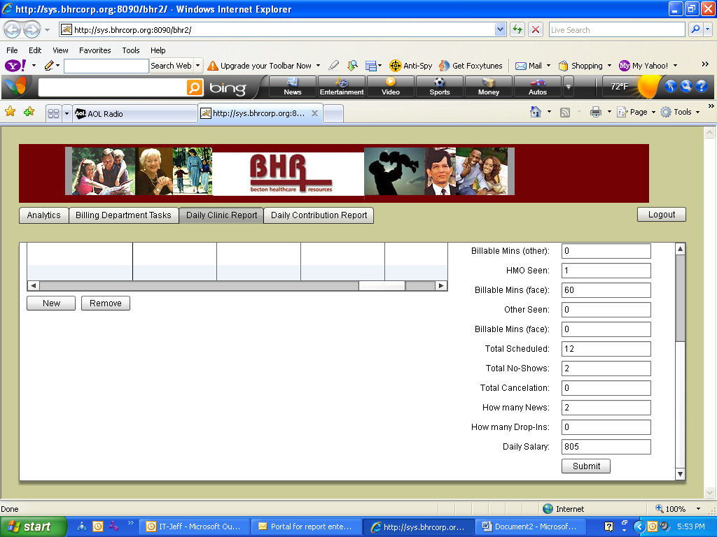
All that is circled in BLUE should be pre -populated…

Hrs Worked (access to manually override)
County Seen
CCC Seen
HMO Seen
Total Scheduled
Total No-shows
Total Cancellation
How many News
How many Drop-ins

Expense %
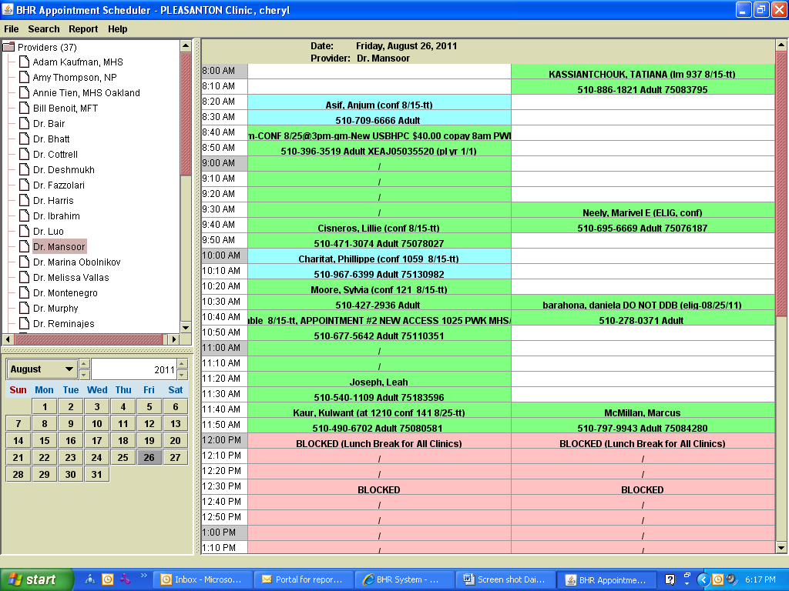
HMO
9. AC
6. AC
2. AC
1. AC
8. AC
7. AC
5. AC
3. AC
4. AC
Private CX 1
Entered in Total cancellation
AC CX 2
Entered in Total cancellation

